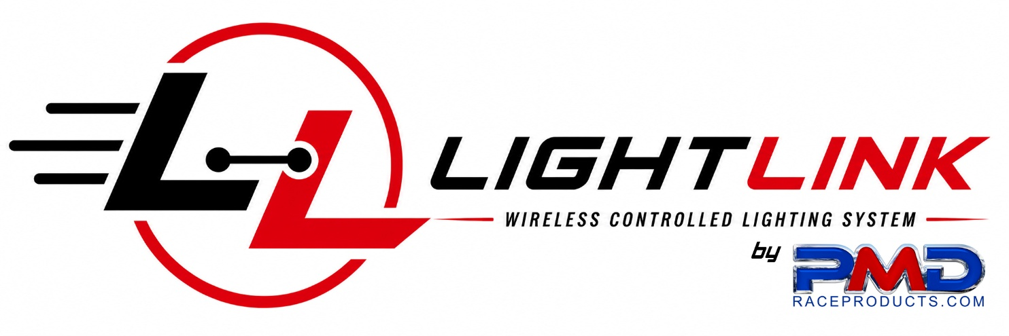

System Overview
LightLink is a wireless race-lighting system built specifically for speedway, karting, motorcycle and motorsport circuits. It replaces or supplements traditional wired lighting and reduces reliance on large numbers of trackside flag marshals, while improving visibility of race conditions across the circuit.
The system draws on PMD Race Products' prior experience supplying custom wireless track lighting and status systems for motorcycle circuits, combined with modern RF technology to deliver an affordable, expandable and practical solution for a wide range of motorsport applications.

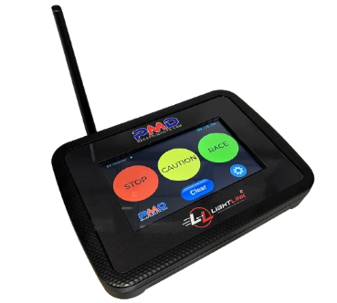
LightLink Race Control
The standard Race Control unit is the central command station used by race officials. It transmits wireless commands to remote lighting stations from a simple 7-inch colour touchscreen, and polls each station for diagnostic feedback.

Display | 7-inch colour touchscreen
Remote stations controlled | Up to 10
Race conditions | Red (Race Stop), Yellow (Track Caution), Green (Race Active)
Station diagnostics | Station ID, wireless signal strength, communication status
Other features | Integrated real-time clock
Built in battery/UPS system | Supplied with AC USB power pack with backup UPS battery onboard

NEW: LightLink Race Control Z5
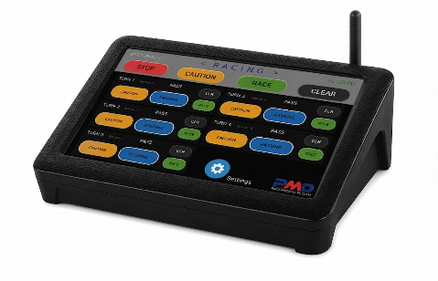
The Z5 is the newest addition to the LightLink range, developed in response to club demand for more advanced control. It introduces multi-zone race-light control on a larger 10.1-inch touchscreen, while remaining fully compatible with existing LightLink remote stations.
Display | 10.1-inch colour touchscreen
Lighting zones | Up to 5 independently configurable zones
Remote stations controlled | Up to 10
Zone assignment | Fully user-configurable – stations can be assigned individually or grouped
Overtaking indication | Zone activation, compatible with 4-colour race lights
Compatibility | Full-course control retained; works with existing LightLink remotes

Examples of Zone control in practice
- An incident at Turn 2 can trigger a yellow caution in that zone only – whilst the rest of the circuit continues under normal race conditions, and the zone is cleared independently once resolved.
- On fast sections, the light station before a known incident area can be grouped into the same zone, so both trackside lights activate together – giving competitors more warning and more time to react.
- Designated zones can be switched to Blue for overtaking indication without affecting the status of any other zone.

Built-in UPS battery backup
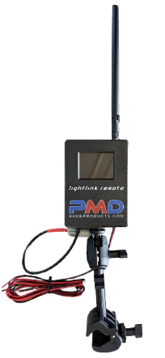
Both the standard and Z5 Race Control units include an internal rechargeable battery and USB-C power adapter. If mains power fails, the unit switches automatically to battery backup, providing up to five hours of continued operation.

LightLink Remote Units
Remote units are installed around the circuit and provide the wireless link between Race Control and each trackside light. They can operate with existing race-lighting hardware or connect directly to PMD Race Products LED race lights.
Power | 12V DC – runs for several days from a standard small car battery
Optional power supply | 240V AC to 12V DC, IP-rated, for permanent track installations
Interface | Local touchscreen showing current race condition
Reporting | Station ID, signal quality, communication status – relayed back to Race Control
Enclosure rating | UV-resistant, weatherproof, chemical-resistant, impact-resistant

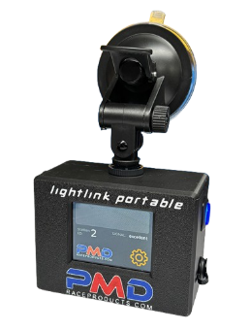
LightLink Portable
Compact, rechargeable units that put race-status information anywhere it's needed – away from fixed
trackside lighting.

Typical uses
- Safety and recovery crews
- Pace cars and response vehicles
- Track officials and race control support staff
- In-car applications, including oval racing
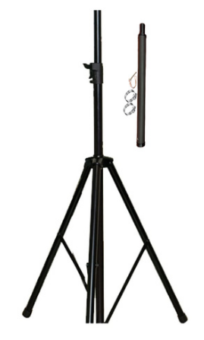
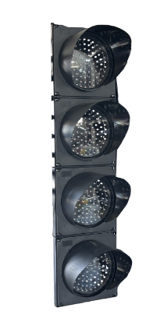
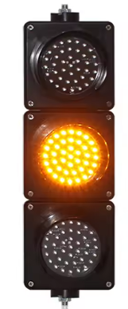
Each LightLink Portable unit displays Green (Racing), Yellow (Caution) or Red (Race Stopped), and includes a rechargeable battery, integrated antenna, touchscreen interface and unique station ID – reporting signal and communication status back to Race Control just like a fixed remote.

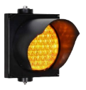
LED Race Lighting Range
100mm and 200mm 3-colour | Red / Green / Yellow
200mm 4-colour | Red / Green / Yellow / Blue
100mm Yellow Piggyback | Connects to existing race lights for extra infield or reverse-direction caution
Portable stands | Available for 100mm and 200mm lights for rapid setup and repositioning
The Piggyback light allows a full-course or zone caution to activate the normal trackside light while simultaneously triggering an infield or reverse-direction warning – giving clubs extra flexibility in how the visual warning system is configured for their circuit.

Real-World RF Range Testing
LightLink has been field-tested across open flat country and hilly, heavily wooded terrain.
Open country | 5km+ range achieved
Hilly / wooded terrain | 2km+ range achieved
Long-range antennas | Available for challenging RF environments or extended range requirements

Designed, Developed and Manufactured in Australia
LightLink is designed, developed and built in-house by PMD Race Products in Mount Gambier, South Australia – covering electronics and PCB design, firmware and control systems, enclosure design, and full assembly and testing.
Enclosures are manufactured in-house using materials selected for UV stability, chemical resistance, high impact strength and temperature resistance, giving us direct control over quality and the ability to keep refining the system.
As a specialised product from a small Australian team, LightLink is produced in relatively small batches to maintain quality control – lead times may vary depending on current demand.

A System That Grows with Your Circuit
LightLink offers a practical path from a simple wireless race-light installation through to a fully configurable multi-zone control system. Whether your circuit needs straightforward full-course control or the advanced zone-based control, caution and overtaking features of the Z5, LightLink can be configured to suit.
If you'd like to discuss which configuration best suits your circuit, contact PMD Race Products on (08) 8725 2895 or sales@pmdraceproducts.com
LightLink – designed, developed and manufactured by PMD Race Products in Australia.
161 Commercial Street East, Mount Gambier South Australia 5290

